Program 8 : To Create and Query a NoSQL Table

Aim:

To create a NoSQL database and table (collection) using MongoDB Compass and perform basic query operations such as insert, find, update, and delete.

Algorithm

1. Open MongoDB Compass and connect to the local MongoDB server.

2. Create a new database and a collection.

3. Insert one or more documents into the collection.

4. Use the Find operation to display the inserted documents.

5. Update the required document using the Update option.

6. Delete a document using the Delete option.

7. Verify the changes and close MongoDB Compass.

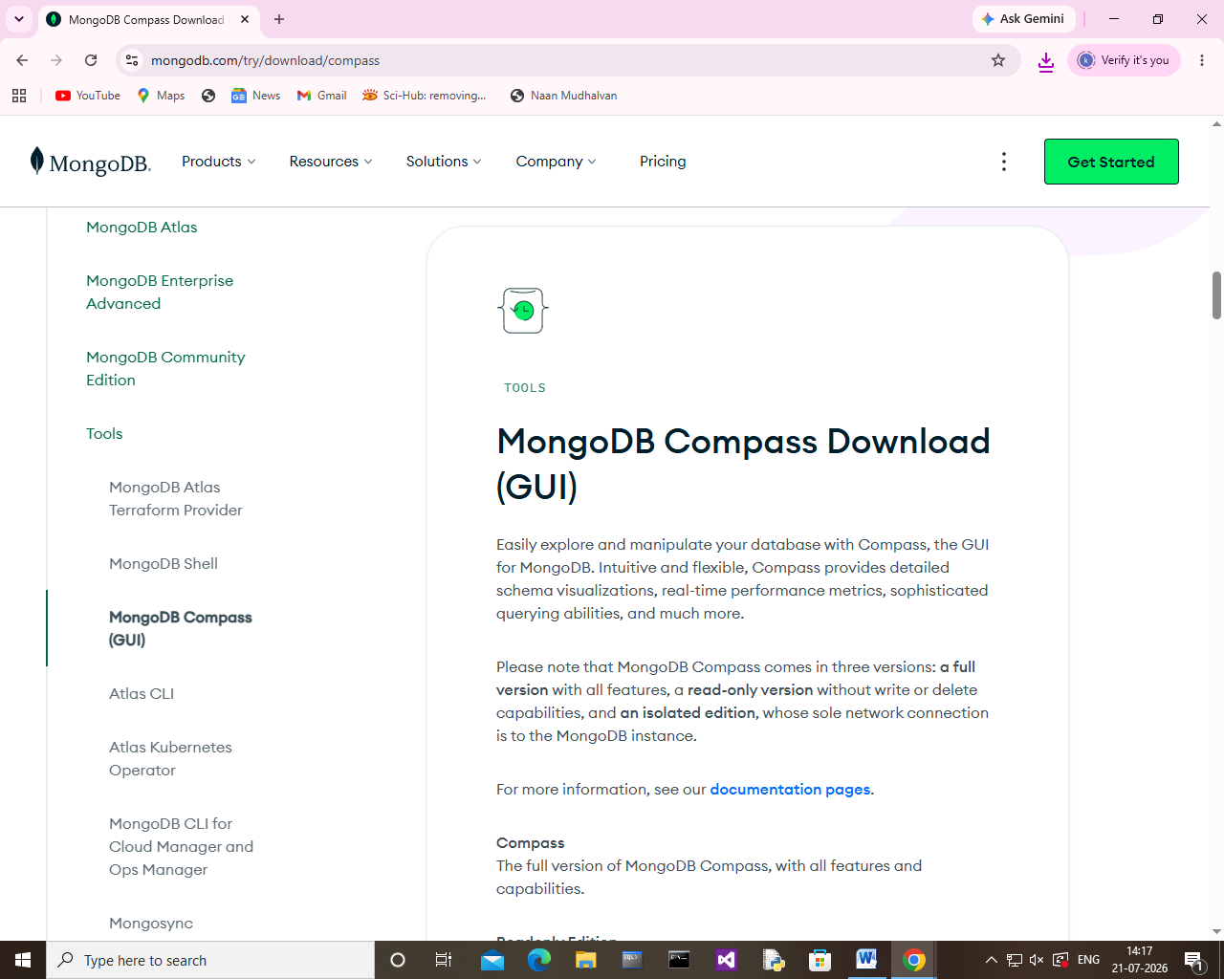

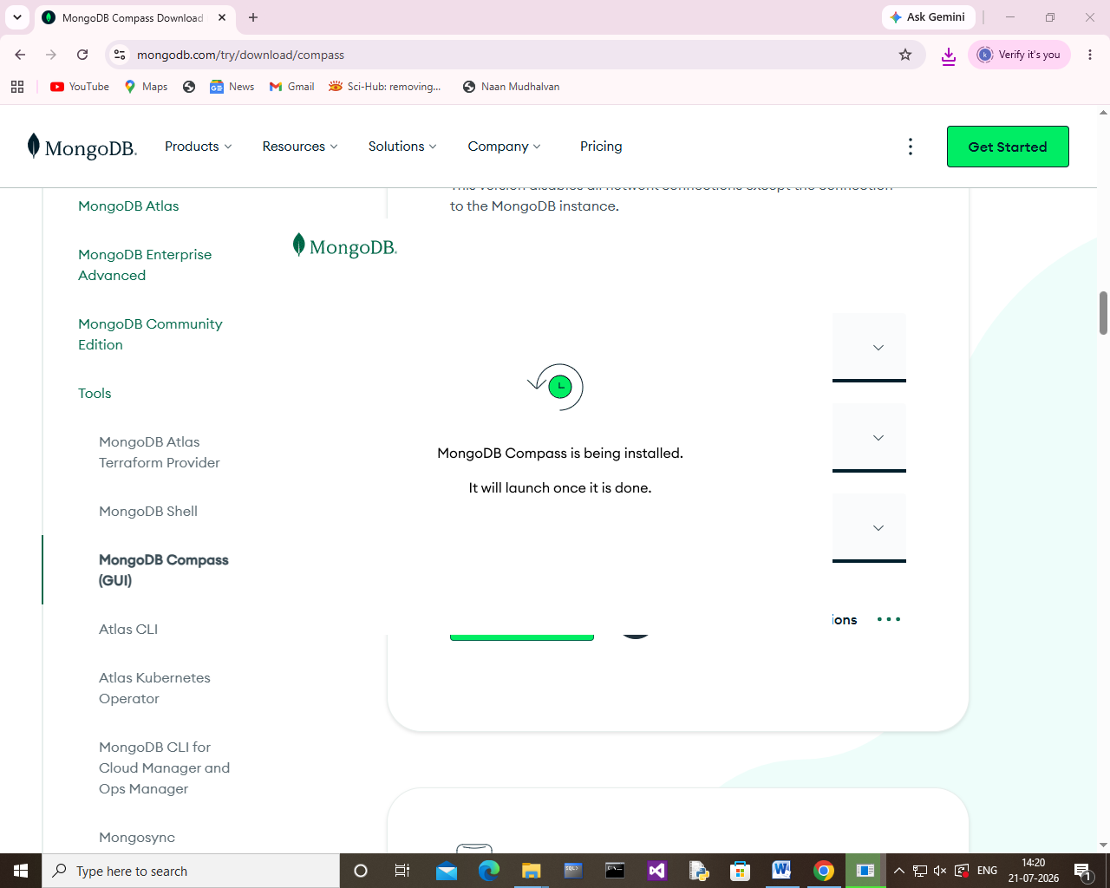

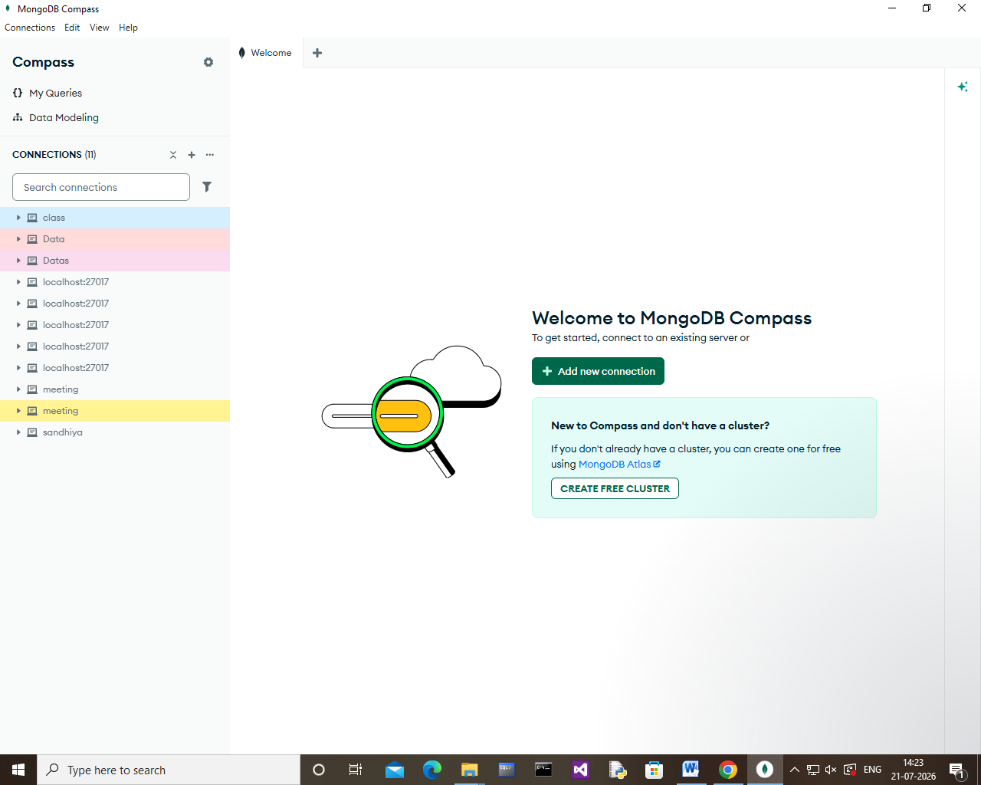

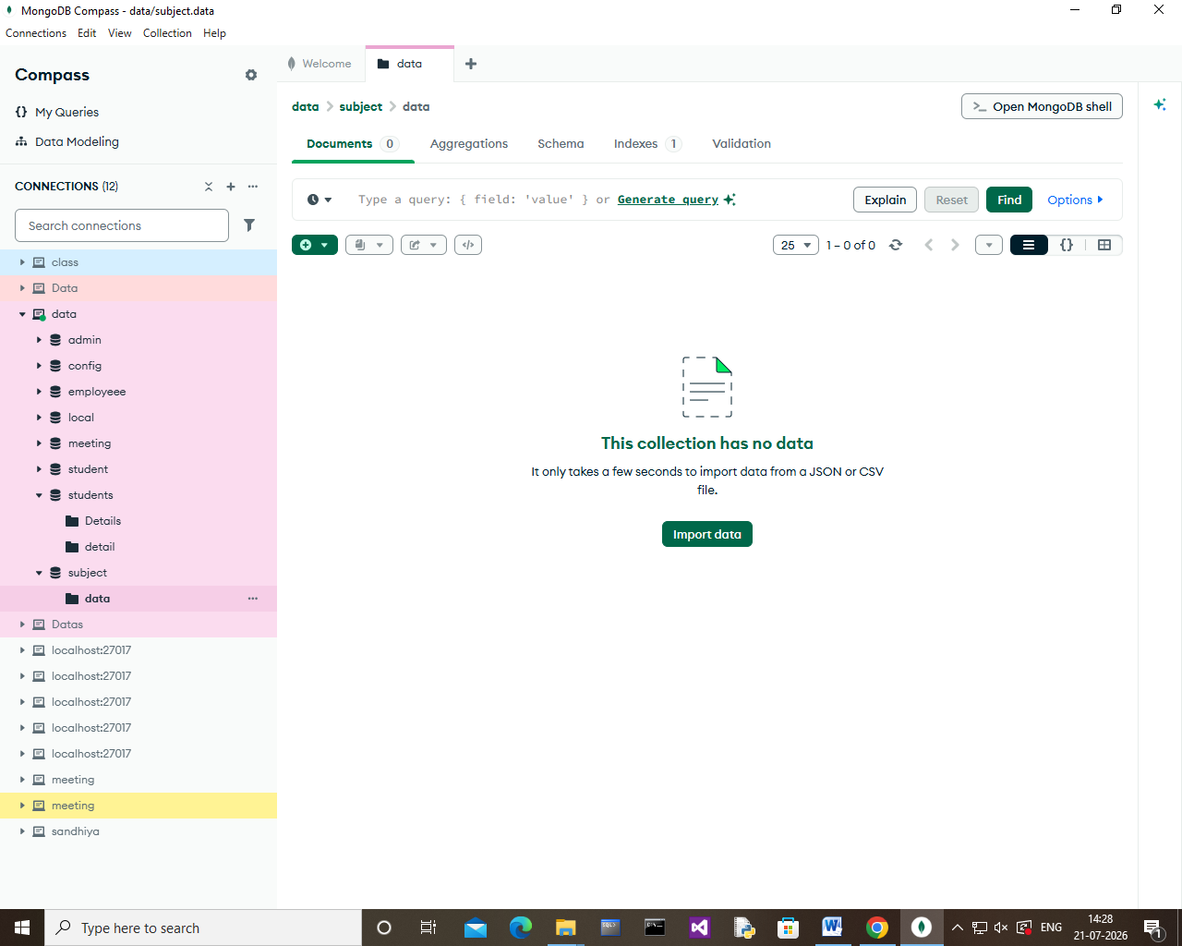

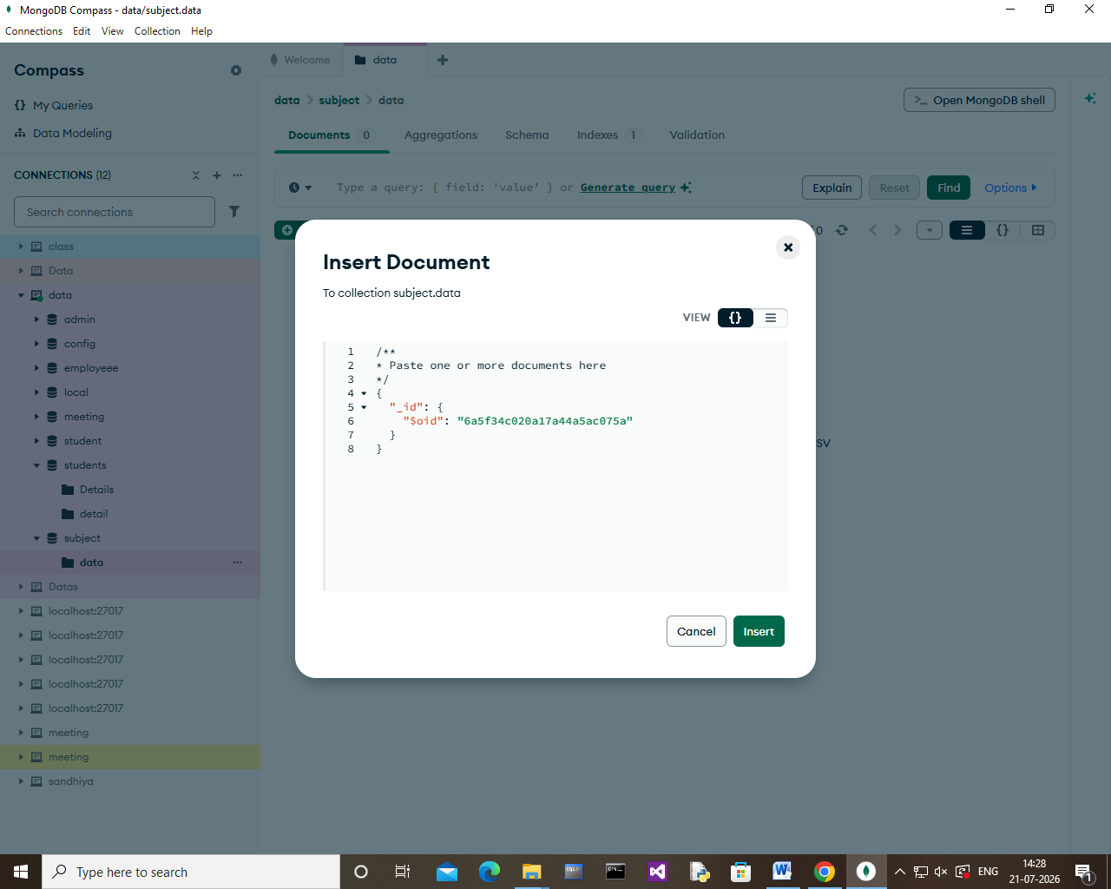

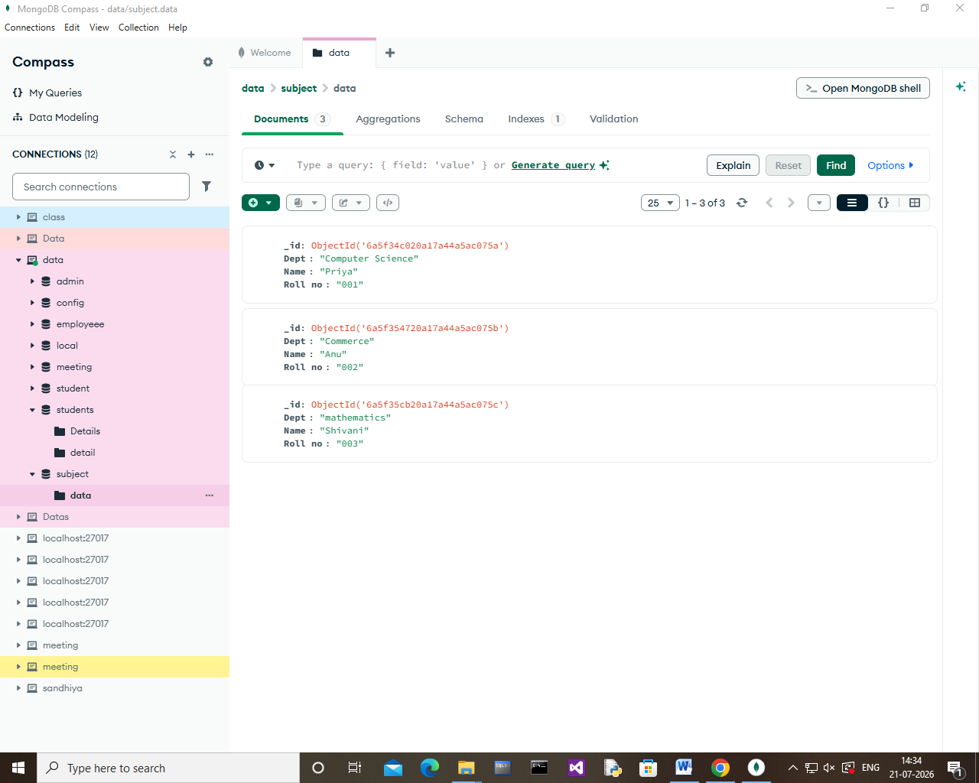
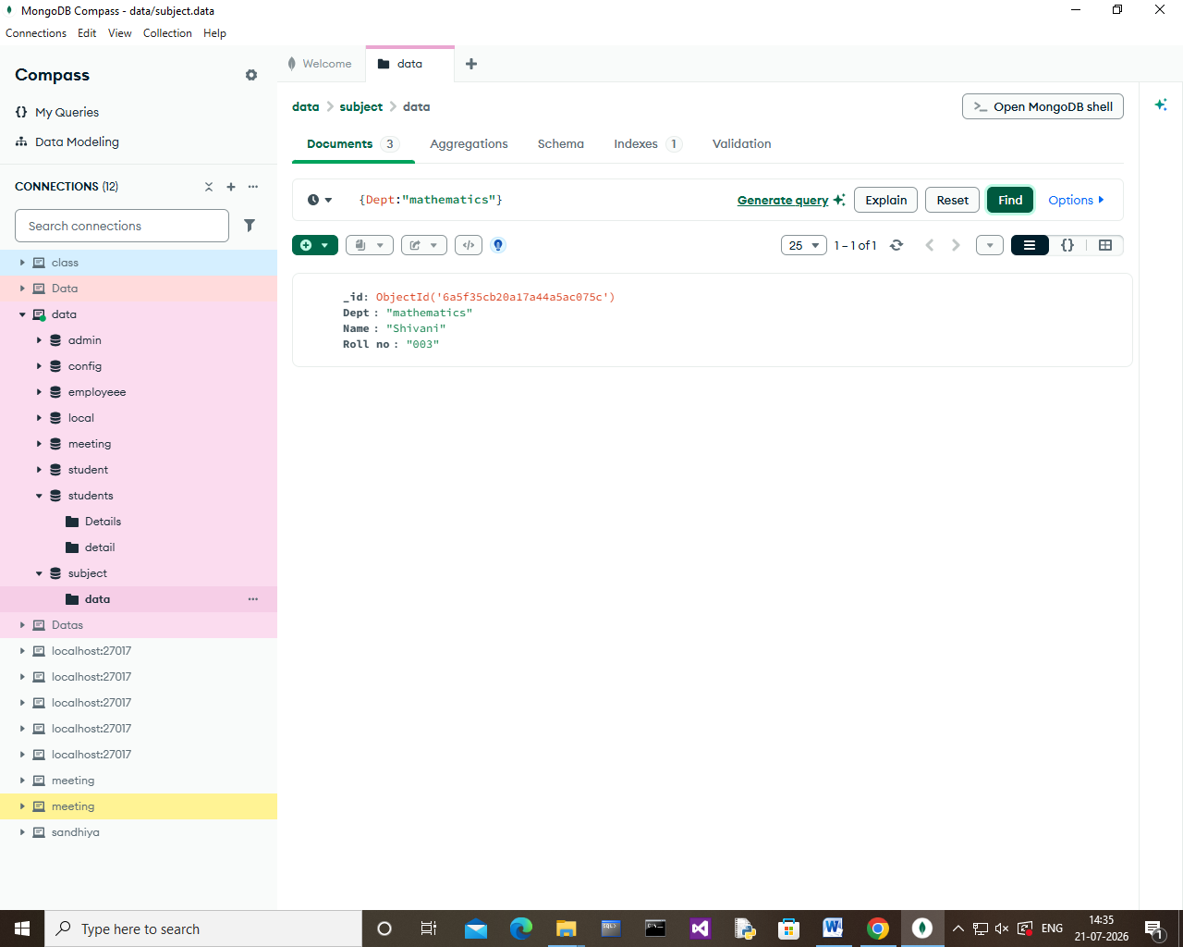

Result:
Thus, the NoSQL database and Collection were created Successfully and the basic Query operations(Insert, Find, Update and Delete) were performed Successfully.

